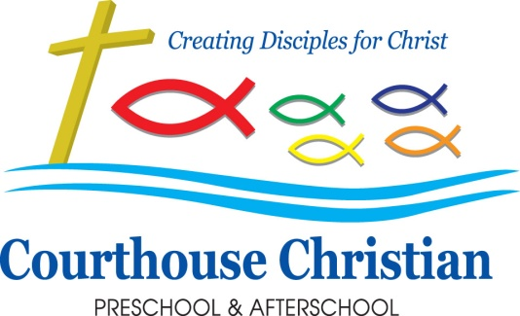

July 2020

A Note from the Office
Happy Summer! September will be here before we know it! We are planning ahead so we will be ready to greet all of our preschoolers!

Preschool Packets
We are doing the distribution of the Preschool Packets different this year. We will be mailing them out to all enrolled families the first week in August. This mailing will include some very important information. There are forms we must receive prior to the first day of school for your child to begin. This packet will include a COVID 19 Handbook which will include all adaptations and information related to the operation of the preschool due to the pandemic. We will include our sanitation and disinfecting policy as well as our new drop off/ pick up procedures.

Meet and Greet
We will be scheduling a time for you and your child to meet their teachers and see the classroom. In order to promote social distancing, each family will have a designated time. This information will be included in the mailed Preschool Packet. The mornings of the Meet and Greet will be September 3rd, 4th and 5th between the hours of 9 am and noon.

Help Keep Us Healthy
When your child arrives to preschool each day, we will check their temperature prior to you departing. We will also be required to ask you several questions about your child’s health including:
Has your child had a fever over 100F or above in the last 24 hours or had fever reducing medication. Let’s help everyone stay healthy by following DHS licensing regulations for sick children. If your child is running a fever, vomiting, has diarrhea, a rash, or colored drainage/discharge, please keep your child home from school. This is one of the best ways to help everyone stay healthy! Children can return from school when they have been symptom- and fever-free for 24 hours without the aid of medication. If your child has to leave school due to illness, please keep in mind these same rules apply. We truly appreciate your cooperation with this issue!

School Pictures: Joyful Years Photography will be coming to the school on September 16th, 17th and 18th to take photos of the children. They will also take pictures of siblings together so if you would like to bring other siblings in, younger or older, we will do those pictures from 8:30a-9:00a on each day. If you are planning on coming early, please come the day your child’s class is scheduled for pictures. If both children attend CCPA then you can let the teachers know and we will make sure to get their picture together during the school day. If you have any questions regarding school pictures, please contact the school office.

Fall Closures: CCPA will be CLOSED on Monday, October 12th for Columbus Day. We will also be closed to all programs on November 25 through November 27 for our Thanksgiving Break.

Important Dates:
September 3,4,5 Meet and Greet
September 8 First Day of School
September 14-18 Scholastic Book Fair
September 15 PTO Zoom Meeting on at 6:30
September 16, 17,18 Picture Day
October 12 Columbus Day- All CCPA programs closed

