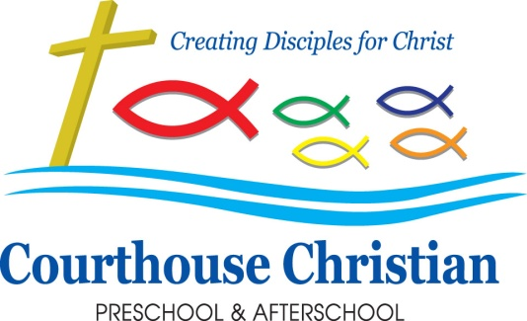
January 2020

Happy New Year!!

2020/21 Preschool Registration
We will begin our registration for next school year on Tuesday, January 21st. We always begin by opening registration to our currently enrolled students and their siblings. Registration will open for CCUMC church members and CCPA Alumni on Monday, January 27th. For the 2020/21 school year, preschool registration will be a flat rate of $185 per child. (This will include a CCPA t-shirt for your child.) We are excited to offer a reduced registration rate of $60 for additional siblings and church members.

Registration forms will be available on Tuesday, January 21st in the office and on the welcome table at the preschool door down by the studio. In order to hold your child’s spot for one of our classes for next school year, we must have the registration form completely filled out and the registration fee paid. Please bring the paperwork and appropriate fee directly to the preschool office. Do not put it in your child’s folder or hand it to your child’s teacher as we cannot guarantee we will get it in a timely fashion. You may hand your registration to the teachers at drive up drop off; however, they will not be able to answer any questions regarding openings or fees.

Registration will be open to the public beginning February 3rd, so we strongly encourage our current families to enroll prior to that date. We cannot guarantee openings in any of our classes once we begin open enrollment. Registration for our afterschool program for elementary age students will happen in April. We will send information home about those programs at that time. If you have any questions, please do not hesitate to contact the office.

Progress Reports and Parent-Teacher Conferences
Your child’s progress report will be sent home on January 30th and January 31st. You may note that this particular progress report is much more detailed than the one you received in November. This is designed to give you an idea of the specific skills your child has been developing throughout the school year thus far. Please keep in mind that children develop at different rates in different areas. In early childhood, there is a wide range of time in which it is considered appropriate for children to develop various skills. For this reason, we do not compare children’s developmental rates to one another; rather, we look for progress within each child. The skills that are assessed are developmentally appropriate and necessary for your child’s success as s/he progress educationally.

We will be offering Parent-Teacher conferences on Monday, February 3rd. There will be no preschool classes that day. Only Full Care children will attend. We would like to encourage you to set a time to visit with your child’s teacher about his or her individual progress, as well as any questions you may have about curriculum or the classroom in general. If you are unable to come to a conference on that day, please talk with your child’s teacher about another date or time for a phone conference or a time to meet in person. Our goal is to work with each individual child to help him or her progress developmentally and prepare him/her for elementary school, when it is time.

Weather Policy Reminder
CCPA school closings due to inclement weather will NOT be broadcast on TV or radio.

In case of inclement weather, we will follow the lead of the Virginia Beach Public Schools. If the public school is delayed 1 hour, preschool will open on a 1-hour delay. (10am) If the public school is closed or delayed due to poor weather, we will also be closed or delayed. In the event the public schools are delayed 2 hours or more, preschool classes will be closed for the day.
In the case of a major weather event, i.e. hurricane, we may choose to re-open before the public schools. Please call the school office for a recorded message.
*For our Extended Care families;
Inclement Weather
- Preschool extended care will operate on the same delay as the VB schools. Note: If Virginia Schools are delayed three hours then our preschool extended care will begin at 10:00am, not 7:00am, and will be open only to students enrolled in full care program.

If you are unsure about a closing, please call the school office at 689-0315 for a recorded message or check our Facebook page.

Outreach News
We had a fantastic response to our December Outreach of Santa’s Workshop. We were able to serve between forty and fifty local needy families, providing a variety of Christmas gifts for their children. Because of you, many local children woke up to a happy and exciting Christmas morning! Thank you for your generosity. We would also like to thank all the amazing parents for volunteering their time on this project!

This month, we will begin to talk about the Epiphany. Our outreach will be for the Winter Shelter Program. Our preschoolers will decorate place mats and bake cupcakes for a special dinner held on January 10.

CCUMC News
Wednesdays are busy evenings here! Consider joining us for free midweek meals! From 5:30-6:30, your family can join us for a meal in the FLC and are invited to stay for all sorts of small group programming afterward. There is something for everyone—even the littlest among us—so consider treating yourself to an easy night and enjoying some fellowship.

Second Cup of Coffee, a parent fellowship and support group on Wednesday mornings, would love to have you join them! Meetings are in the Cry Room following preschool drop off. Young children are welcome.

End of Year Tax Statements
If you would like a statement for the 2019 year, please let Kenda know in the office and we will get one in your child’s folder.

Donation Corner
Tis the season to be super aware of germs! If you are able, we would truly appreciate donations of the following: tissues, hand sanitizer, Clorox wipes, baby wipes, and Ziploc bags of all sizes. Thank you!

Upcoming Dates
January 20—Martin Luther King, Jr. Day—CCPA CLOSED
January 21—Registration for 2020/21 opens for currently enrolled families
January 27—Registration for 2020/21 opens for CCUMC and alumni
January 30 & January 31—Progress Reports sent home
February 3—Parent Teacher Conference Day—No preschool classes. Extended care programs ONLY.
February 3—Registration for 20120/21 opens to the public
February 17—President’s Day—CCPA CLOSED

