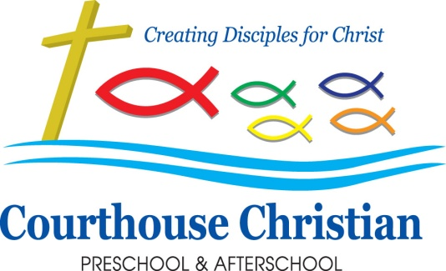
February 2019
“Love each other as I have loved you.” John 15:12

A Note from the Office
Welcome, February! Our hearts are full of kindness around here, and we are excited to celebrate Wear Red for CHD (Congenital Heart Defect) Awareness Day. We ask all staff and children to wear RED on Thursday, February 7.
1 in 110 children are born with these heart defects. We know several of our families have children that are heart warriors.

2019/20 Preschool Registration
Registration for the 2019/20 school year has started! We are continuing to offer 2, 3, and 5 day classes for children ages two to five. If you have friends looking for a dynamic, nurturing, and safe learning environment for their preschoolers, we would be happy to share what is going on at CCPA. Some of our classes are filling quickly. If you are interested in learning and growing with us next year and have not yet registered, please feel free to drop by the office or call us at 689-0315!

Chapel and Outreach Updates
We are excited to say we completed our January outreach project. In January, we talked about the Epiphany and caring for all of God’s creatures. We knew that we can be the hands and feet of God when we care for God’s creatures, and so we made treats and toys for the Virginia Beach SPCA. A special thank you to all families who were able to donate old towels or blankets—the SPCA was extremely grateful for everything they received!

This month, we have continued talking about God’s love and how He wants us to love others. The children are very excited to make valentines for the residents of a local assisted living facility! We will be sharing the Valentine’s at Chapel on February 6 and 7. Feel free to make Valentines at home to send in for the residents. These will be collected in time for delivery on Valentine’s Day. They also discussed how much they love and want to make valentines for their families, friends, and pets. Some of you may be getting some pretty special cards soon! 😊

Class Pictures
Class pictures are here! These pictures were taken in September, so if your child was not enrolled at that time, they will not be in the picture. We are in the process of working on our amazing playground! The playground committee has big dreams. Class Pictures are $5 apiece and this money will go toward the playground! We are calling our Fund Raiser “A Picture-Perfect Playground!” Pictures are in the office and you may pay by either cash or check. Thanks!

Read Across America
We are so excited to have Grow Smart sponsor a Read Across America event here at CCPA on Friday, March 1! This year’s read is Happy by Pharrell Williams. Community Volunteers will visit our classrooms that morning and read the book to the children. Our teachers will plan a quick activity for the volunteers to do with the children. Every child will receive a book to take home!

President’s Day
All CCPA programming will be closed on Monday, February 18th for President’s Day.

Pastries for Parents
Looking ahead into March, we would like to cordially invite all parents to a special breakfast to share that we’re calling Pastries for Parents. Please come enjoy coffee, tea, pastries, and some time with your child! If you are unable to attend, it is perfectly fine to invite another special adult in your child’s life to join us. Our goal is to honor all of the adults who do the most important job of all--the “parent job”-in our children’s lives.
Pastries for Parents will be Thursday, March 21st for our T/TH and 5-day classes and on Friday, March 22nd for our MWF classes.

Summer Camp 2019
We are so excited about our Summer Programming! We are adding some extra camps this summer and we are so excited! We are even offering a 2-year-old camp the weeks of June 3rd and 10th. Ms. Megan has agreed to lead it! More details about all camps will be out March 1st.

Upcoming Activities
February 6th & 7th —Outreach Chapel
February 12th – Parent/Teacher Organization Meeting, 6:30pm; come help us plan for Teacher Appreciation Week
February 18th—President’s Day (CCPA CLOSED, all programs)
February 21st&22nd—Dentist Visit with Dr. Roxzanne
March 1st—Read Across America day
March 11th & 12th – Spring Pictures
March 21st & 22nd—Pastries for Parents

